**Build Data Dashboard Project**

**Data Set Used:** Flight Delays and Cancellations.

**Insight 1.**

**Dashboard:** Cancellation Report

**Link:**

<https://public.tableau.com/profile/iayushgupta#!/vizhome/CancellationReport_16192143247640/CancellationReport>

**Summary:**

Chicago O’Hare International Airport had the greatest number of flight cancellations (405 flights). Most of these flights were cancelled due to Weather (217 flights cancelled), which peaked in the month on February (54 flights). America Eagle Airline Inc. (MQ) had the maximum number of flight cancellations.

Generally, Weather was the reason for the greatest number of flight cancellations (2397 flights), with it peaking in the month of February (728 flights).

Southwest Airlines Co. (WN) had the greatest number of flights cancelled (818 flights), with weather contributing maximum.

**Design:**

Used different colour for each cancellation reason.

Line chart was used to show the trend of cancellations through the months.

Used stacked bar chart to show the various reasons for cancellation and their count for each Airline.

**After feedback:** Changed the colour palette to work for the colour-blindness. Also, added the titles for better understanding.

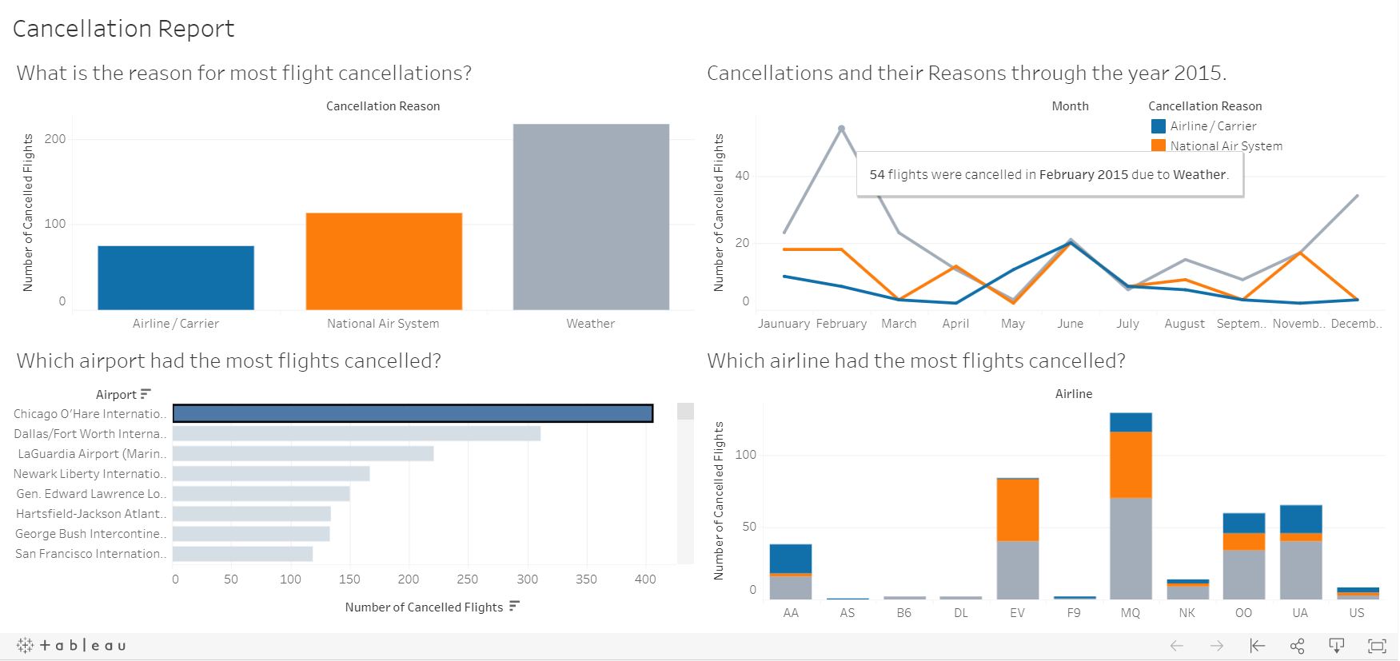

Screenshot from the Cancellation Report Dashboard.

**Insight 2.**

**Dashboard:** Delay Report

**Link:**

<https://public.tableau.com/profile/iayushgupta#!/vizhome/DelayReport_16193596360140/DelayReport>

**Summary:**

The map shows us state wise delay (in minutes). We can see that Texas (TX) had the maximum total delay of 1,115,426 minutes.

We can also see that departure delay caused the maximum amount of delay amounting to 2,649,459 minutes.

Southwest Airlines Co. had the maximum total delay of 1,546,569 minutes.

The month of June had the maximum total delay of 1,136,010 minutes.

Chicago O’Hare International Airport had the maximum total delay 623,809 minutes, with departure delay contributing 200,115 minutes, and United Air Lines Inc. contributing 144,838 minutes. The month June had the maximum total delay of 93,400 minutes.

**Design:**

Used different colour for each type of delay.

Line chart was used to show the trend of delay through the months.

Used stacked bar chart to show the various reasons for delay and the amount of delay they caused (in minutes) for each Airline.

Bar chart was used to show the delay cause by each reason and also for each airport.

A simple filled polygon map was used to show the total delay throughout the American Continent.

**After feedback:** Changed the colour palette to work for the colour-blindness. Also, added the titles for better understanding.

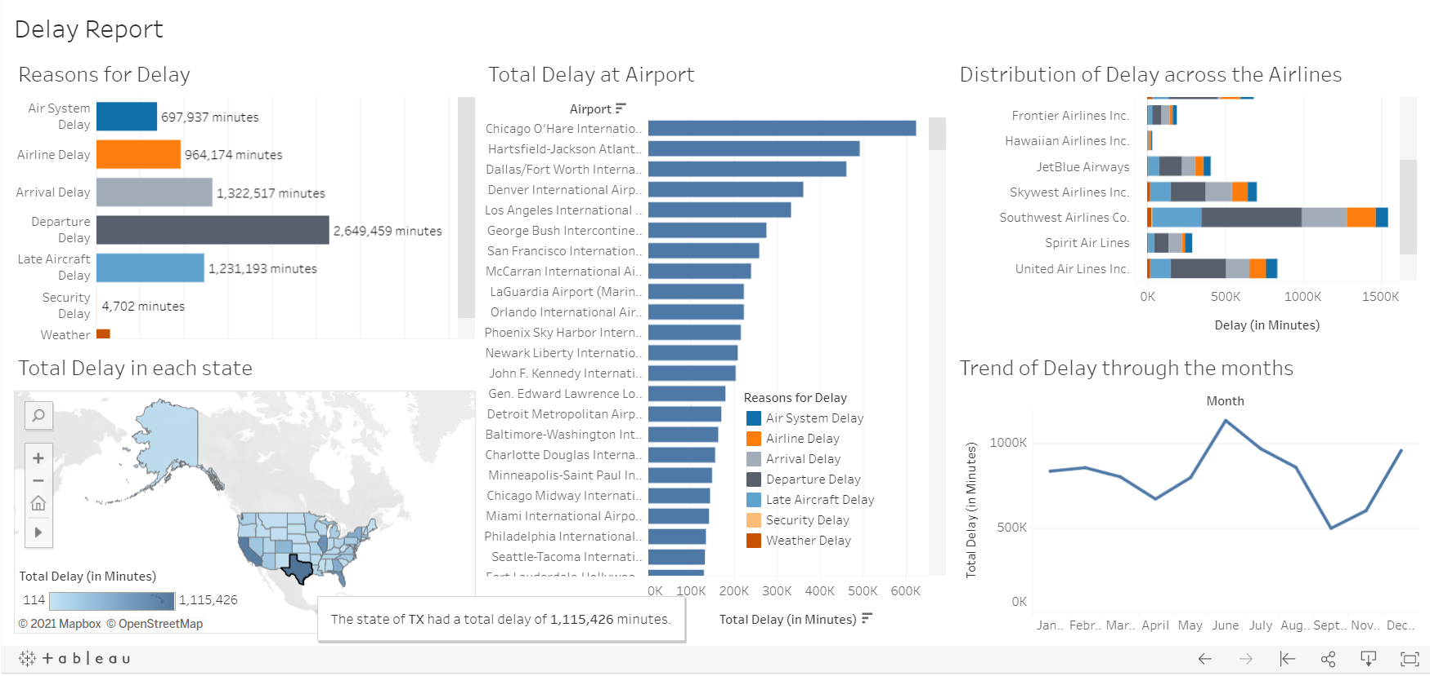

Screenshot from the Delay Report Dashboard.

**Insight 3.**

**Dashboard:** Flights Scheduled

**Link:**

<https://public.tableau.com/profile/iayushgupta#!/vizhome/Book1_16204694922910/FlightsScheduled>

**Summary:**

Hartsfield-Jackson Atlanta International Airport (ATL) had the maximum number of flights scheduled for departure (18,056 flights).

Monday was the day on which most flights were scheduled for departure (41,016 flights).

26,810 was the maximum number of flights that were scheduled for departure, it was in the month of July.

The map shows the route of a flight from the origin airport to the destination airport with the airline operating it.

As we saw, Hartsfield-Jackson Atlanta International Airport (ATL) had the maximum number of flights scheduled for departure, with maximum of them being in the month of July (1,759 flights).

In the month of July, Wednesday was the day when the most flights were scheduled for departure (299 flights).

**Design:**

Used a dark background for the map for better visibility with the lines and circles being bright coloured for the same reason. I made this flights route map for a nice visual experience as well as a better way to provide the insight.

Line charts were used to show trends through the months as well as days. I decided to omit the include zero option so as to see the visualization more clearly.

Used a bar chart for the showing the total number of flights scheduled for each airport.

**After feedback:** Added the titles for better understanding. Also, we can use the airline filter on the map to see the routes that the airline operates from that origin airport.

**Reference:** <https://www.theinformationlab.co.uk/2020/09/14/how-to-create-an-origin-destination-map-in-tableau/>

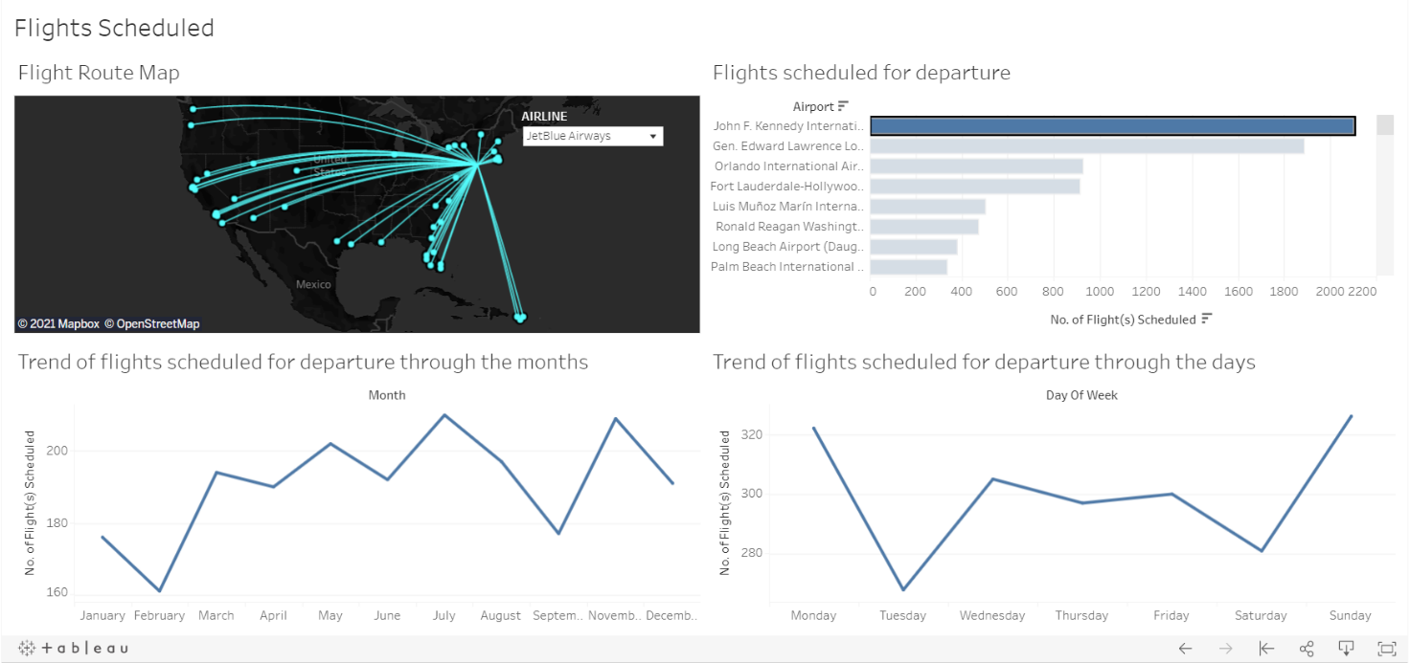

Screenshot from the Flights Scheduled Dashboard.